Smart Bridge Assignment3

Md Danish Anwar (20BCE0106)

Implement JDBC connectivity using Java

**Create Table**

Before that, first, create one table and add some entries into it.

**Below is the SQL query to create a table.**

|  |
| --- |
| **create** **table** employee_details (empNum number(10), lastName **varchar**(50),   firstName **varchar**(50), email **varchar**(255) , deptNum number(10), salary number(10)); |

Created the “employee_details” table in Oracle DB.

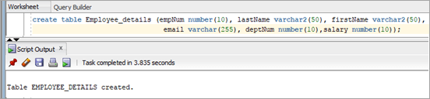

**Insert Data Into Table**

Using the following queries, insert the data into the “employee_details” table.

|  |
| --- |
| **insert** **into** employee_details **values** (1001, 'Luther', 'Martin', 'ml@gmail.com', 1, 13000);  **insert** **into** employee_details **values** (1002, 'Murray', 'Keith', 'km@gmail.com', 2, 25000);  **insert** **into** employee_details **values** (1003, 'Branson', 'John', 'jb@gmail.com', 3, 15000);  **insert** **into** employee_details **values** (1004, 'Martin', 'Richard', 'rm@gmail.com', 4, 16000);  **insert** **into** employee_details **values** (1005, 'Hickman', 'David', 'dh@gmail.com', 5, 17000); |

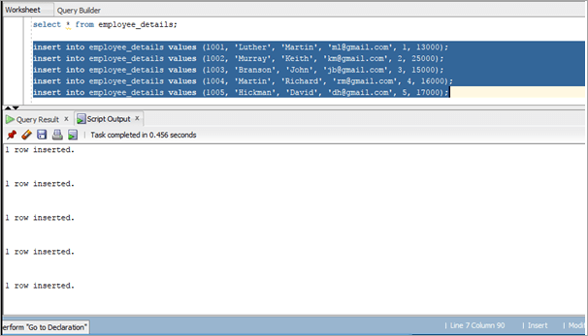

**Java Program**

**Download the JDBC jar file and import it into the Java project.**

|  |
| --- |
| **package** com.STH.JDBC;      // import sql package to use it in our program  **import** java.sql.*;    **public** **class** Sample_JDBC_Program {    **public** **static** **void** main(String[] args) **throws** ClassNotFoundException, SQLException {          // store the SQL statement in a string          String QUERY = "select * from employee_details";          //register the oracle driver with DriverManager          Class.forName("oracle.jdbc.driver.OracleDriver");          //Here we have used Java 8 so opening the connection in try statement  **try**(Connection conn = DriverManager.getConnection("jdbc:oracle:thin:system/pass123@localhost:1521:XE"))          {                  Statement statemnt1 = conn.createStatement();                  //Created statement and execute it                  ResultSet rs1 = statemnt1.executeQuery(QUERY);                  {                      //Get the values of the record using while loop  **while**(rs1.next())                      {  **int** empNum = rs1.getInt("empNum");                          String lastName = rs1.getString("lastName");                          String firstName = rs1.getString("firstName");                          String email = rs1.getString("email");                          String deptNum = rs1.getString("deptNum");                          String salary = rs1.getString("salary");                          //store the values which are retrieved using ResultSet and print it                      System.out.println(empNum + "," +lastName+ "," +firstName+ "," +email +","+deptNum +"," +salary);                      }                  }          }  **catch** (SQLException e) {              //If exception occurs catch it and exit the program              e.printStackTrace();          }         }      } |

